Types Of Programming Languages

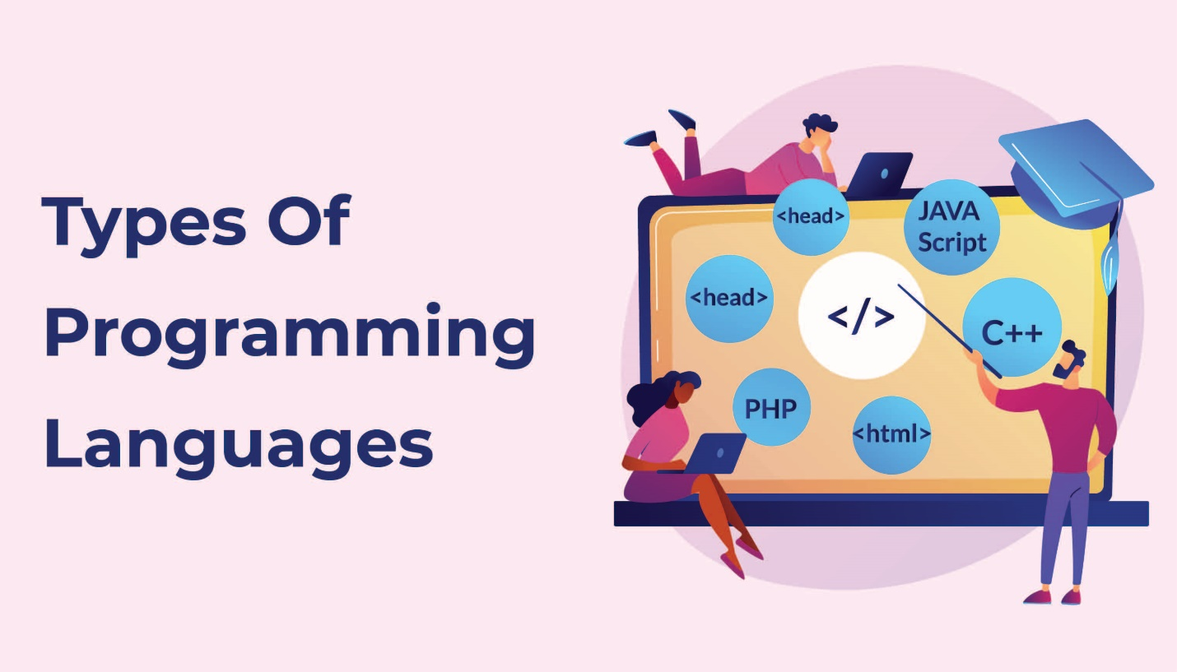

**A Programming Language** is a way for humans to give instructions to a computer. It's a bridge between what we understand and what the computer can execute, turning ideas into action.

**Why Do We Need Programming Languages?**

Computers only understand binary (0s and 1s), which is hard for humans to write. Programming languages help us write instructions that can be translated into the machine's language.

**Basic Components of a Programming Language**  
  
**1. Syntax:**

* *The rules that define how a program should be written.*

**2. Semantics:**

* *The meaning behind the instructions.*

**3. Compiler/Interpreter:**

* *A tool that translates code into something the computer can understand.*

**Types of Programming Languages**

**A. Based on Machine Interaction**

* **Low-Level Languages:** Directly communicate with hardware and are difficult to understand.  
  Examples: Assembly, Machine Code.
* **High-Level Languages:** Closer to human language and easier to write.  
  Examples: C, Java, Python, C#.

**B. Based on Execution Method**

* **Compiled Languages:** The entire code is converted into machine code before running.  
  Examples: C, C++, Rust.
* **Interpreted Languages:** Code is executed line-by-line during runtime.  
  Examples: Python, JavaScript.
* **Hybrid (Compiled + Interpreted):** First compiled into an intermediate format, then interpreted at runtime.  
  Examples: C#, Java.

**C. Based on Programming Paradigm**

* **Procedural:** Code is written in a sequence of steps (functions).  
  Examples: C.
* **Object-Oriented (OOP):** Code is organized using objects and classes.  
  Examples: C#, Java, Python.
* **Functional:** Focuses on using functions and immutability.  
  Examples: Haskell, Lisp, JavaScript.

**Compiled vs. Interpreted Languages**

|  |  |  |
| --- | --- | --- |
| **Feature** | **Compiled Languages** | **Interpreted Languages** |
| **Execution Speed** | Faster (pre-compiled) | Slower (line-by-line) |
| Compilation | Required (before running) | Not required (runs directly) |
| **Error Detection** | Errors detected before running | Errors detected during runtime |
| Portability | Less portable (compiled for specific OS/CPU) | More portable (runs on any system with interpreter) |
| **Debugging** | Harder (requires recompilation) | Easier (debug in real-time) |

**Is C# a Compiled or Interpreted Language?**

* C# is both compiled and interpreted

**Why Does C# Use Both Compilation and Interpretation?**

* **Portability:** IL is platform-independent, so the code can run on any system with the .NET runtime (CLR).
* **Performance:** JIT compiles only the necessary parts of the code, improving efficiency.
* **Security:** IL goes through security checks before execution.
* **Dynamic Features:** Some C# features, like reflection and dynamic types, need runtime execution.

**What is an Integrated Development Environment (IDE)?**

* An **IDE** is a tool that helps developers write, test, and debug code. It combines everything you need in one place to make development easier and faster.

**Key Features of an IDE:**

* **Code Editor:** A text editor that helps you write code with features like auto-completion.
* **Compiler/Interpreter:** Translates the code into machine-readable instructions.
* **Debugger:** Helps you find and fix errors.
* **Build Automation:** Handles tasks like compiling and packaging your code.
* **Version Control:** Helps manage and track changes in the code.
* **Project Management:** Organizes your files and resources for large projects.

**Popular IDEs:**

* **Visual Studio (C#, .NET)**
* **IntelliJ IDEA (Java, Kotlin)**
* **Eclipse (Java, C++)**
* **A blue logo with a black background

  AI-generated content may be incorrect.PyCharm (Python)**
* **A hammer on a blue square

  AI-generated content may be incorrect.VS Code (Multiple languages)**
* **A blue letter a with a green head and black circle

  AI-generated content may be incorrect.Xcode (Swift, Objective-C)**
* **Android Studio (Android development)**

**Why Are IDEs Important?**

* **Boosts Productivity:** Provides tools like auto-completion and debugging.
* **Reduces Errors:** Real-time error detection improves code quality.
* **Enhance Collaboration:** Integrates with version control systems.
* **Supports Multiple Languages:** Many IDEs support various languages.